Network Threats and Mitigation & Physical Security and Risk
Tasks
1. Create a table listing 5 common network threats (such as phishing, DDoS, man-in-the-middle, malware, and password attacks), and for each, write one real-world example from an app or service you use (like WhatsApp, Instagram, or Paytm).

Table of 5 Common Network Threats & Real-World Examples
Threat Type | Description | Real-World App Example
1. Phishing | Deceptive messages or fake login pages designed to trick users into revealing sensitive credentials. | Fake SMS alerts mimicking Paytm claiming a KYC block to steal banking passwords.
2. DDoS (Distributed Denial of Service) | Overwhelming a server with massive automated bot traffic to crash services and block legitimate users. | Traffic floods targeting Zomato servers during peak festival dinner hours to disrupt ordering.
3. Man-in-the-Middle (MitM) | Intercepting data packets flowing between a user and a server on an insecure network. | Eavesdropping on unencrypted or compromised public Wi-Fi networks to read chat packets on WhatsApp.
4. Malware | Malicious software (trojans, spyware) disguised as legitimate apps to steal local device data. | Fake modded APK downloads of Instagram from third-party sites containing keyloggers.
5. Password Attacks (Credential Stuffing) | Automated scripts rapidly trying lists of leaked usernames and passwords until an account is breached. | Automated login attempts using leaked credential databases on user accounts across Instagram.

2. Simulate a brute-force attack scenario by writing a simple Python script that tries to guess a 4-digit PIN code by checking all possible combinations against a preset value.The script should print the number of attempts it took to guess the correct PIN.

Simulate a Brute-Force Attack Using Python

1. Aim
To create a simple Python program that simulates a brute-force attack by checking all possible 4-digit PIN combinations until the correct PIN is found.

2. Python Code
# Brute Force Attack Simulation
# Preset 4-digit PIN
correct_pin = "2580"attempts = 0
# Check all possible 4-digit combinations
for i in range(10000):
guess = str(i).zfill(4)
attempts += 1
if guess == correct_pin:
print("PIN Found:", guess) print("Total Attempts:", attempts)
break

3. Expected Output
PIN Found: 2580
Total Attempts: 2581

4. Explanation
- First, we set a preset 4-digit PIN.
- The program generates combinations from 0000 to 9999.
- It checks each combination against the correct PIN.
- Every guess increases the attempt counter by one.
- When the correct PIN is found, the program displays the PIN and total number of attempts.

5. Result
Successfully created a Python program to simulate a brute-force attack and calculate the number of attempts required to guess a 4-digit PIN.
Security Note: This is an offline educational simulation using a preset PIN, not an attack on a real account or device. 🔐

3. List 4 physical security risks that could affect a server room hosting a popular app like Zomato or BookMyShow, and suggest one mitigation step for each risk.

4 Physical Security Risks & Mitigations for a Server Room
- Unauthorized Physical Access
  - Risk: Intruders or unauthorized personnel gaining direct physical entry to tamper with servers or steal hardware.
  - Mitigation: Install biometric access control systems (fingerprint/retina scanners) and keycard logging at all entry points.
- Fire Hazards and Electrical Overloads
  - Risk: Overheating or electrical short circuits leading to catastrophic server damage.
  - Mitigation: Install an automated clean-agent gaseous fire suppression system (like FM-200) that extinguishes fires without destroying hardware with water.
- Power Outages and Voltage Surges
  - Risk: Sudden power grid failures causing abrupt shutdowns, data corruption, and hardware failure.
  - Mitigation: Deploy enterprise-grade Uninterruptible Power Supply (UPS) units and backup diesel generators.
- Environmental / Water Damage
  - Risk: Leaking plumbing pipes or air conditioning condensation dripping onto active server racks.
  - Mitigation: Install water leakage sensors beneath raised floors and keep server racks away from overhead plumbing lines.

4. Draw a simple floor plan (hand-drawn or digital) of a small office and mark at least 3 physical security measures you would implement to protect network equipment (such as CCTV, biometric access, or cable locks).
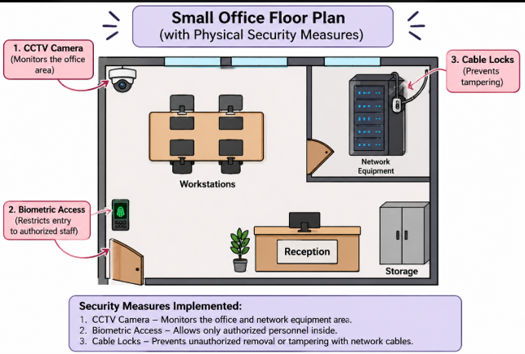

5. Use ChatGPT or a similar AI tool to generate a checklist of 7 actions a network admin should take to mitigate risks from both network threats and physical security breaches, then review and edit the checklist to make it specific for a college computer lab environment.

Security Checklist for a College Computer Lab

1. Introduction
A college computer lab contains computers, networking devices, servers and important student data. A network administrator must protect the lab from both network threats and physical security breaches.

2. Checklist – 7 Important Security Actions
S.No. | Security Action | How to Implement in a College Lab
1. | Install Antivirus Software | Install updated antivirus software on all lab computers to protect against viruses and malware.
2. | Use Strong Passwords | Create strong passwords for student accounts, admin accounts and Wi-Fi networks.
3. | Enable Firewall Protection | Configure firewalls to block unauthorized network access.
4. | Install CCTV Cameras | Place CCTV cameras near computer systems, servers and network equipment.
5. | Restrict Physical Access | Allow only authorized staff to enter the server and networking equipment room.
6. | Secure Network Devices | Use cable locks and locked racks to protect routers, switches and servers from theft or damage.
7. | Regular Backup and Updates | Regularly back up important student data and update operating systems and network devices.

3. Review and Editing
After reviewing the checklist, I made it specific to a college computer lab by including:
- Protection of student records and login credentials.
- Security of computers used by students.
- Restricted access to server rooms.
- CCTV monitoring of lab equipment.
- Regular software updates and data backups.

4. Conclusion
Network security and physical security are both important for a college computer lab. By following these seven security actions, a network administrator can reduce security risks, protect important data and maintain a safe computing environment.

5. Result
Successfully generated, reviewed and customized a seven-point security checklist for protecting a college computer lab from network threats and physical security breaches. 🔐

